**СТРУКТУРА УРАВЛЕНИЯ**

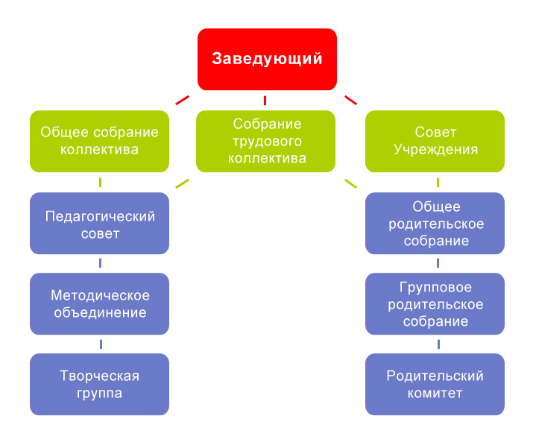

[](http://yandex.ru/images/search?source=wiz&img_url=http://img0.liveinternet.ru/images/attach/c/3/75/740/75740260_431.png&uinfo=sw-1366-sh-768-ww-1349-wh-673-pd-1-wp-16x9_1366x768-lt-354&text=%D0%BA%D0%B0%D1%80%D1%82%D0%B8%D0%BD%D0%BA%D0%B8%20%D0%B4%D0%BB%D1%8F%20%D0%B4%D0%B5%D1%82%D1%81%D0%BA%D0%BE%D0%B3%D0%BE%20%D1%81%D0%B0%D0%B4%D0%B0&noreask=1&pos=21&lr=63&rpt=simage&pin=1)