***Добрый день!***

**Давайте, познакомимся!**

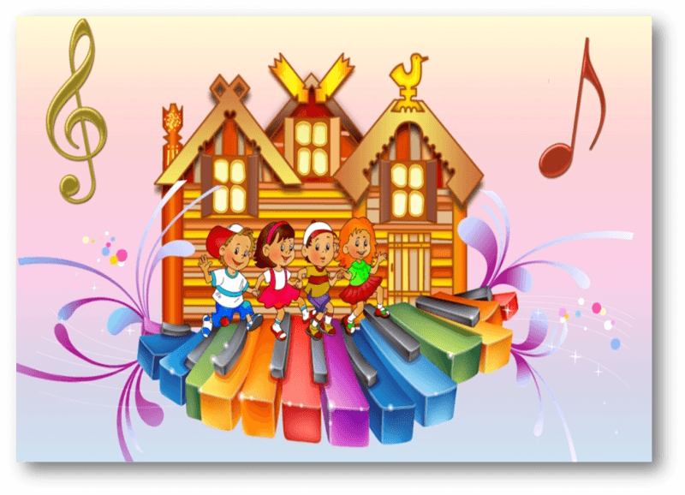

[*https://www.youtube.com/watch?v=3qa7AH2ABHk&feature=emb_logo*](https://www.youtube.com/watch?v=3qa7AH2ABHk&feature=emb_logo)

***Видеть музыку:***

[*https://www.youtube.com/watch?v=TuuVHOmM1Zc&feature=emb_logo*](https://www.youtube.com/watch?v=TuuVHOmM1Zc&feature=emb_logo)

**

*Поиграем в повторялки:*

[*https://yadi.sk/d/HTBNmmNuwguTWg*](https://yadi.sk/d/HTBNmmNuwguTWg)