

***Здравствуйте!***

**Развиваем память:**

[**https://yadi.sk/i/J7SBV84c0dmcGQ**](https://yadi.sk/i/J7SBV84c0dmcGQ)

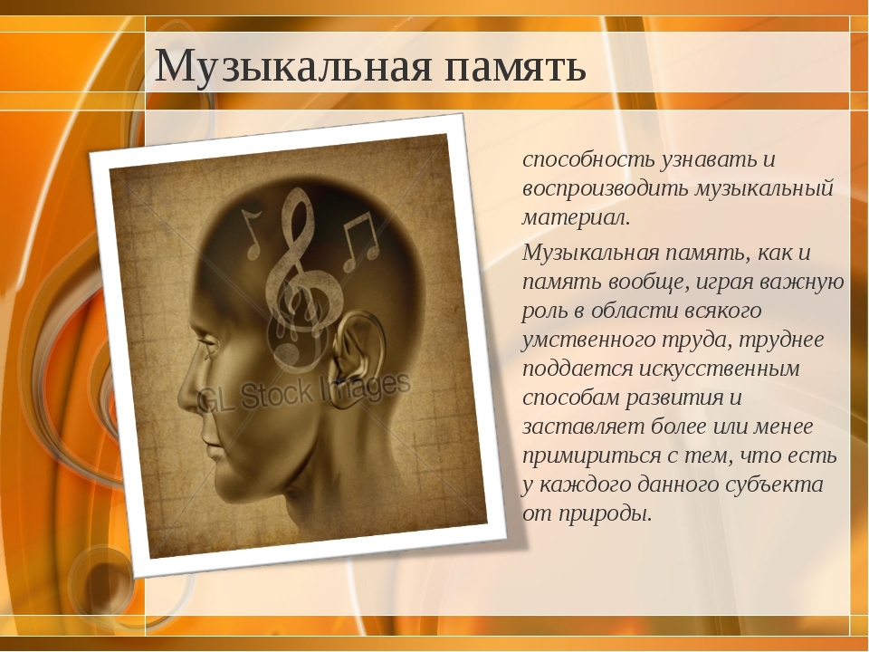

**Кухонный оркестр:**

[**https://www.youtube.com/watch?v=FdAbJcgxz2I&feature=emb_err_watch_on_yt**](https://www.youtube.com/watch?v=FdAbJcgxz2I&feature=emb_err_watch_on_yt)

