***Здравствуйте!***

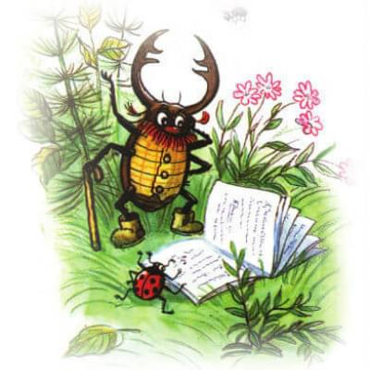

[***https://www.youtube.com/watch?v=xxJFl3qSkCc&feature=emb_logo***](https://www.youtube.com/watch?v=xxJFl3qSkCc&feature=emb_logo)

***Занятие «Осень»***

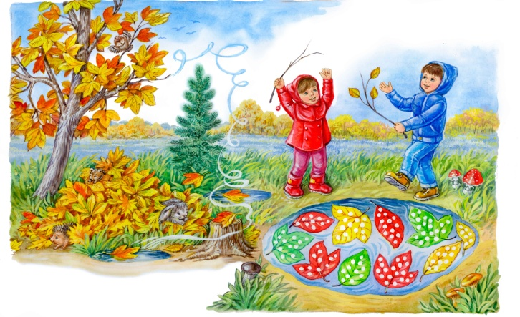

[***https://yadi.sk/i/GKUxnPG0ycTMHQ***](https://yadi.sk/i/GKUxnPG0ycTMHQ)