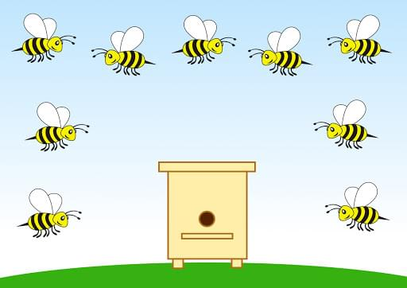



***Пальчиковая игра «Дом для пчелки»***

[***https://www.youtube.com/watch?v=l_qNXtU-TGc&feature=emb_logo***](https://www.youtube.com/watch?v=l_qNXtU-TGc&feature=emb_logo)

[***https://www.youtube.com/watch?v=QuqQcy6DsGE***](https://www.youtube.com/watch?v=QuqQcy6DsGE)

