

***Здравствуйте!***

**«Зайка, попляши!»**

[**https://www.youtube.com/watch?v=pzkB0eg0VT8&feature=youtu.be&fbclid=IwAR0-g73xGWCaCkj-34DQXXNch-WO0QUA79BKs6zUYfV1KQNqJnK76a4qLLM**](https://www.youtube.com/watch?v=pzkB0eg0VT8&feature=youtu.be&fbclid=IwAR0-g73xGWCaCkj-34DQXXNch-WO0QUA79BKs6zUYfV1KQNqJnK76a4qLLM)

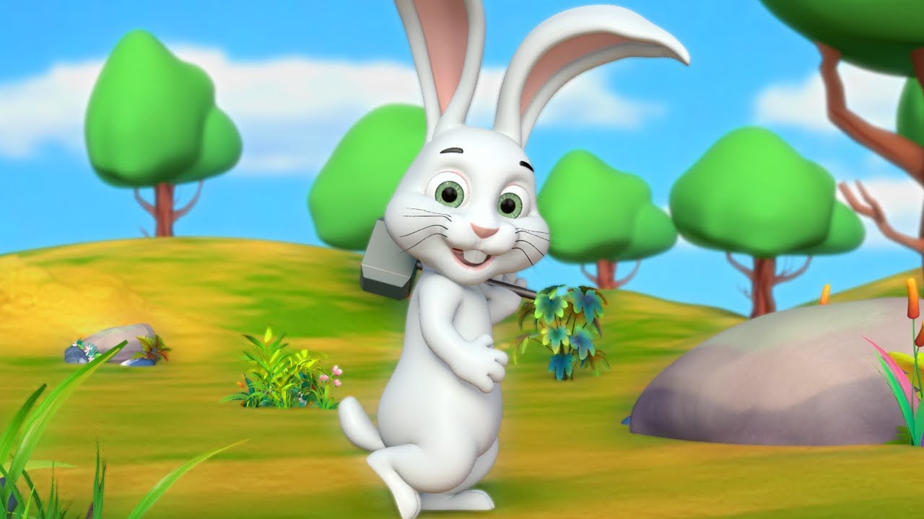

**Музыкальные инструменты**

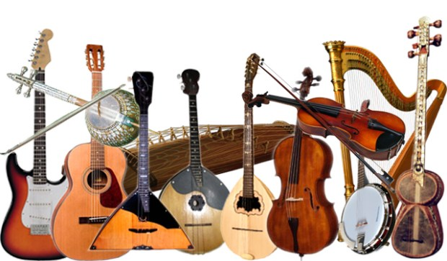[**https://www.youtube.com/watch?v=WCkDcGpQ4oE&feature=emb_logo**](https://www.youtube.com/watch?v=WCkDcGpQ4oE&feature=emb_logo)